🟢 Bandit Level 4 → Level 5
After logging in as bandit4, run:
ls -al to view hidden files
You'll see:
inhere
Go inside:
cd inhere
now list ls-al
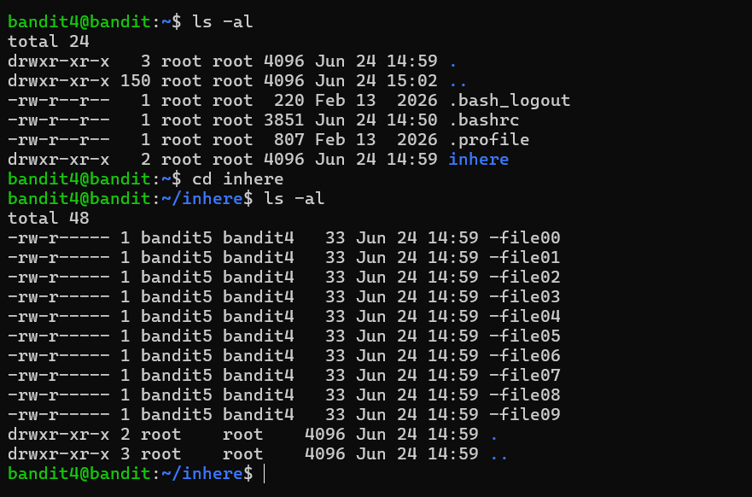
You'll see several files like:
-file00
-file01
-file02
...
-file09
🎯 Goal: Find the file containing human-readable text.
You can check all files using:
file ./*
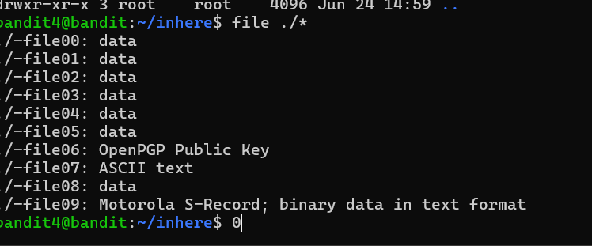
Look for the one reported as ASCII text.
Then read that file:
cat ./-file07
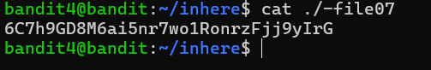
🔑 The output is the password for bandit5. 6C7h9GD8M6ai5nr7wo1RonrzFjj9yIrG
Then exit

